The Friends of Harmony Barbershop Chorus and Quartets

Home for the Harmonies: A Barbershop Christmas

Friday December 5th, 2025 | 7:30PM

Ellicott Creek Playhouse
530 Ellicott Creek Road, Tonawanda, NY 14150
Niagara Regional Theatre Guild | Current Season
Online Tickets ($20) available at:
Home for the Harmonies: A Barbershop Christmas Tickets | Tonawanda, NY | Ellicott Creek Playhouse
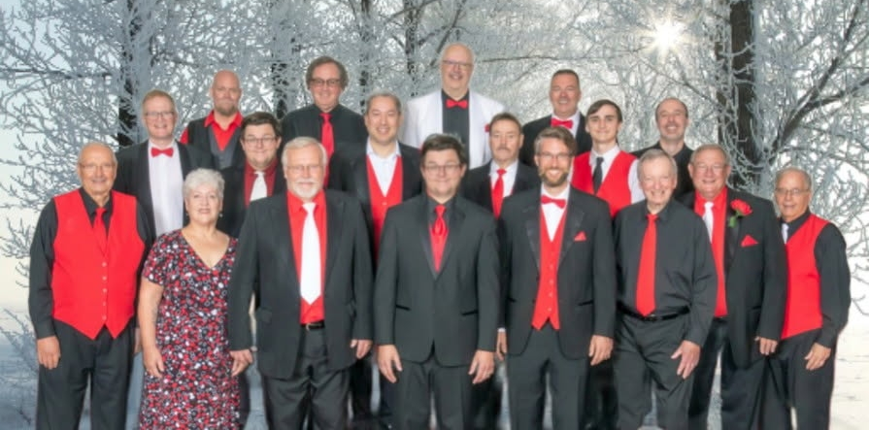
Get ready to be swept away by the festive magic of “Home for the Harmonies” – a barbershop Christmas concert! Join us on Friday December 5th for an evening filled with heartwarming melodies and timeless holiday classics.
This concert, presented by Friends of Harmony, promises to bring joy, laughter, and a touch of nostalgia to your holiday season. Don’t miss out on this enchanting musical experience!

