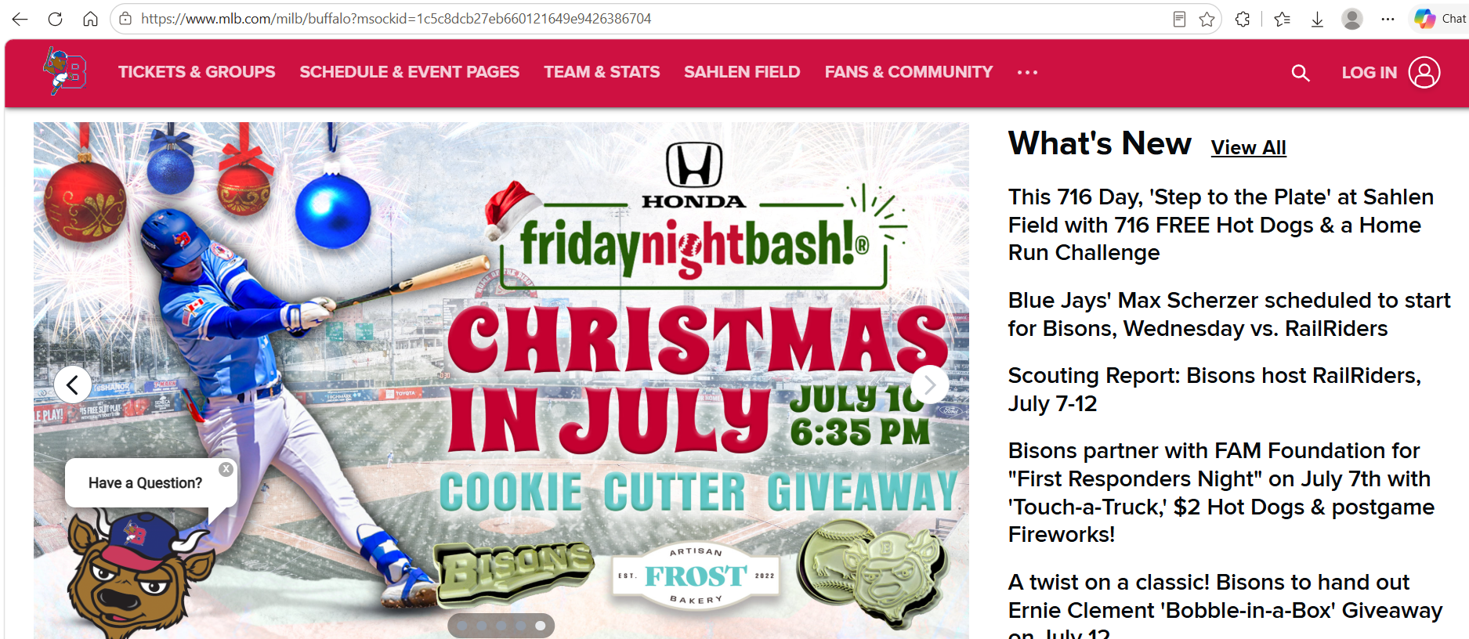.
Friends of Harmony
Fri. July 10
National Anthems at 6:20 PM
First Pitch 6:35 PM
Christmas Songs Before & Fireworks!

